Group A report

Milestone 5: Dynamics & Animation
This milestone extends the procedural terrain generator developed in previous milestones by introducing dynamic behavior, stochastic effects, and performance evaluation. The previously generated terrain was static; therefore, this phase focused on transforming it into an interactive environment with animation, particle effects, and efficiency analysis.
The main objectives were:
- To introduce temporal behavior through terrain animation.
- To implement a stochastic particle system for environmental realism.
- To evaluate animation efficiency using performance metrics.
- To analyze system stability and visual realism.

Animation System Implementation
- Camera Rotation Animation
A real-time animation system was implemented using the Matplotlib FuncAnimation framework.
The camera position changes gradually across frames, creating a rotating view around the procedural terrain.

Implementation concept:
At every frame:
- The previous frame is cleared.
- The terrain is redrawn.
- The camera angle is updated.
- The next frame is generated.

Result:
The terrain can be viewed from different angles, allowing interactive exploration of the generated landscape.

Procedural Terrain Motion
To introduce temporal behavior, the terrain height values were modified using a sinusoidal function.
The height update follows:
Z_new = Z_original + A sin(t)
Where:
- Znew= updated terrain height
- Zoriginal = original generated terrain height
- A= movement amplitude
- t= animation time/frame
The sinusoidal function creates smooth and continuous movement instead of sudden changes.

Purpose:
- Simulates natural environmental motion.
- Maintains procedural consistency.
- Avoids unrealistic sudden terrain changes.

Stochastic Particle System
A stochastic fog particle system was added to improve environmental realism.
The particle system generates random points positioned above the terrain surface.
Each particle contains:
- X coordinate
- Y coordinate
- Height position
The particles are generated using random sampling:
random.uniform()

Particle generation process:
- Select random terrain locations.
- Obtain corresponding terrain heights.
- Place particles slightly above the terrain.
- Render particles during animation.

Particle Visualization
The particles are displayed using a 3D scatter plot:
ax.scatter(
fog_x,
fog_y,
fog_z,
s=5,
alpha=0.5
)

Result:
The terrain environment contains a fog effect that improves atmospheric appearance.
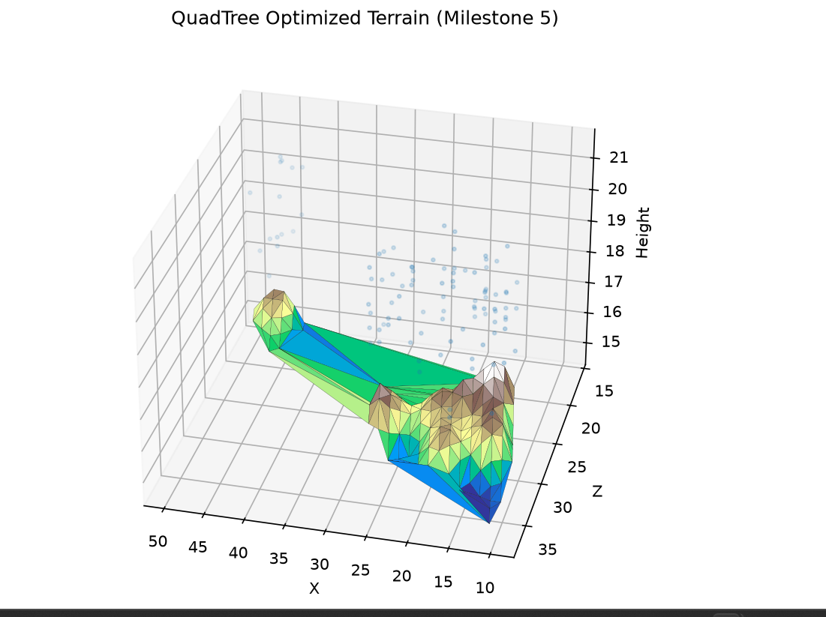

Efficiency and Performance Analysis
To evaluate animation efficiency, frame performance was measured using Frames Per Second (FPS).
The FPS calculation:
FPS = 1 / FrameTime
Where:
- FrameTime = time required to generate one animation frame.
Implementation:
frame_time = time.time() - start_time
fps = 1 / frame_time

The FPS values were displayed during execution.
Example results:

Test | Observation
Terrain rotation | Smooth movement
Fog particles added | Slight performance reduction
Continuous execution | Stable operation

Stability Evaluation
The system was tested during continuous execution.
Evaluation criteria:
Criterion | Result
Program crashes | No
Terrain rendering errors | No
Animation continuity | Stable
Particle rendering | Successful
Performance monitoring | Successful

Observation:
The system maintained stable operation while rendering procedural terrain, animation, and stochastic particles simultaneously.

Realism Evaluation
The improvements introduced in Milestone 5 increased the realism of the procedural environment.

Terrain realism
- Variable terrain heights.
- Non-flat landscape generation.
- Procedural variation.

Animation realism
- Smooth camera movement.
- Continuous environmental behavior.

Atmospheric realism
- Fog particles simulate environmental conditions.

Final Results
The completed Milestone 5 system successfully transformed the procedural terrain generator from a static visualization into a dynamic environment simulation.
The final system includes:
✅ Procedural terrain generation
✅ QuadTree optimization
✅ 3D terrain visualization
✅ Camera animation
✅ Stochastic fog particle system
✅ FPS performance monitoring
✅ Stability evaluation

Conclusion
Milestone 5 successfully demonstrated the integration of efficiency techniques and stochastic methods into a procedural terrain generation system. The addition of animation and particle-based effects improved the realism of the generated environment while maintaining acceptable performance.
The evaluation showed that the system was capable of producing dynamic terrain visualization with stable rendering performance.

